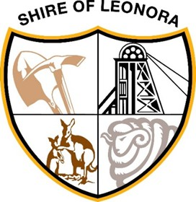

SHIRE OF LEONORA

PUBLIC NOTICE

SCHEDULED MEETING DATE CHANGE
Local Government Act 1995 (Section 5.25G)

The dates for the Ordinary Meeting of Council and the Audit, Risk and Improvement Committee Meeting to be held on Tuesday 15th September 2026 have been changed to Tuesday 22nd September 2026.
Commencement times and venue for both meetings will remain as is.

Ty Matson
Chief Executive Officer
Shire of Leonora
PO Box 56
LEONORA WA 6438
Phone: (08) 9037 6044

